Project Report (Part I)

*on*

**Implementation of Thyroid Disease Prediction System using Machine Learning Techniques**

*Submitted in partial fulfillment for the award of the degree*

*of*

BACHELOR OF ENGINEERING

*In*

COMPUTER ENGINEERING

(SEM-VII)

submitted by

|  |
| --- |
| Viral Haria  Suraksha More  Bijal Patel |

***Under the Guidance of***

Mrs. Harshali Patil

Assistant Professor & ME Coordinator



**University of Mumbai**

**Department of Computer Engineering (2018-19)**



**CERTIFICATE**

This is to certify that Mr. Viral Haria, Ms. Suraksha More, Ms. Bijal Patel are bonafide students of Thakur College of Engineering and Technology, Mumbai. They have satisfactorily completed the requirements of the PROJECT-I as prescribed by University of Mumbai while working on “Implementation of Thyroid Disease Prediction System using ML Techniques”.

|  |  |  |
| --- | --- | --- |
| **Mrs. Harshali Patil**  **(Guide)** | **Dr. Sheetal rathi  ( HOD CMPN)** | **Dr. B. K. Mishra**  **(Principal)** |
| **Internal Examiner: External Examiner:**  **Signature with Date:………….. Signature with Date:…………..**  **Name:…………………………….. Name:…………………………**   |  | | --- | | Thakur College of Engineering and Technology  Kandivali(E), Mumbai-400101. |   PLACE: Mumbai  DATE: 01/10/2018 | | |

**ACKNOWLEDGEMENT**

We sincerely thank our guide Mrs. Harshali Patil for her guidance and constant support and also for the stick to our backs. We also thank the project coordinators for arranging the necessary facilities to carry out the project work.

We thank the HOD, Dr. Sheetal Rathi, Dean Academic, Dr. R.R Sedamkar, the Principal, Dr. B. K. Mishra and the college management for their support.

**Viral Haria (Roll No 30)**

**Suraksha More (Roll No 57)**

**Bijal Patel (Roll No 65)**

**ABSTRACT**

Disease diagnosis is not an easy task, especially without proper equipment. This problem can be solved using some machine learning techniques. Till now there has been various researches and heart diseases, or so have been predicted appropriately using such techniques. Not much work has been done on thyroid and so, in this project we try to implement prediction of thyroid disease system. This project builds a system which helps predict a normal person about his possibility of getting thyroid in future. This system will also help doctors to better diagnose their patients and provide proper treatment in time. The algorithm is first trained using the data set available from UCI repository and then tested on the data set. Then the user enters his details and the algorithm starts running, according to the values entered by the user the algorithm predicts that the user will be having thyroid in future or not. This system will help doctors as well as individuals to have a possible disease diagnosed. And once a person predicts whether or not he can be diagnosed with thyroid disease in the future, our system will be giving suggestions like blogs of experts, doctors etc. recommending home remedies, homeopathic and ayurvedic medicine suggesting sites etc.

**INDEX**

|  |  |  |  |
| --- | --- | --- | --- |
| **Chapter No.** | **Topic** | | **Pg. No.** |
|  | * List of figures | | **I** |
|  | * List of Tables | | **II** |
| **Chapter 1** | **Introduction** | |  |
|  | 1.1 | Introduction |  |
|  | 1.2 | Motivation |  |
|  | 1.3 | Problem Definition |  |
|  | 1.4 | Objectives of the Project |  |
|  | 1.5 | Scope of the Project |  |
|  | 1.6 | Applications of the Project |  |
|  | 1.7 | Project Impact Analysis |  |
|  | 1.8 | Expected Outcome of the Project |  |
|  | 1.9 | Organization of the Project Report |  |
| **Chapter 2** | **Literature Review and Proposed Work** | |  |
|  | 2.1 | Literature Survey |  |
|  | 2.2 | Proposed Work |  |
| **Chapter 3** | **Requirement Gathering, Analysis and Planning** | |  |
|  |  |  |  |
|  | 3.1 | Requirement Specification |  |
|  | 3.2 | Feasibility Study |  |
|  | 3.3  3.4  3.5  3.6 | Methodology  Technology  Gantt Chart and Process Model  System Analysis (functional model, structural model and behavioral model) |  |
| **Chapter 4** | **Design Phase** | |  |
|  | 4.1  4.2  4.3  4.4 | Block Diagram/ Software architecture  Algorithm/Flowchart/Pseudocode Design  User Interface Design (Snapshots)  Database Design, Data structure design |  |
| **Chapter 5** | **Conclusion**  **References** |  |  |

**Base Research Paper**

**Appendix A**

* Abbreviation and symbols

**Appendix B**

* Definitions

**List of Figures**

Figure 1: Use Case Model

Figure 2: Object Model

Figure 3: User Interface

Figure 4: Gantt Chart

Figure 5: Waterfall Model

Figure 6: DFD Level 0

Figure 7: DFD Level 1

Figure 8: Deployment Diagram

Figure 9: Activity Diagram

Figure 10: Use Case Diagram

Figure 11: Flowchart

Figure 12: User Interface Design Snapshots

**Chapter 1**

**Introduction**

**1.1 Introduction**

Diagnosis of diseases is a very complex and difficult task, requiring a lot of experience and knowledge. Usually people physically go to doctors’ clinics for regular checkups or for diagnosis of some symptoms of any disease. The thyroid gland, situated near the base of the throat, secrets a hormone thyroxine which controls many of the metabolic processes like blood pressure, body weight and temperature. The thyroid disease can be caused due to an under-secretion or an over-secretion of thyroxine. Thyroid disease is very common illness among people living in hilly regions. The symptoms of this disease are usually not easily detected because it varies depending on the type and hence proper medicines cannot be provided on time. Diagnosis can often be done with laboratory tests. There are numerous tests for different types of this disease and we aim to accurately predict each type. [For this, we have made provision for the user to enter each result of almost any tests for our system to predict the likelihood of occurrence of the disease.] Data mining and machine learning is the way of semi-automatically classifying and analyzing large datasets to find what amount of the data can be grouped into a single category and then using those categories to accurately predict from the new, growing datasets.

**1.2 Motivation**

Thyroid being a common disease in a country like India, not much research has been done for the same. People do not pay much attention to the symptoms and hence a proper treatment cannot be given in time. If there is a system wherein people can enter their details and find out the chances of them being affected by thyroid then it makes it easy for people and also helps in spreading more awareness. Doctors also can encourage their patients to use the system on a regular basis to keep their health in check.

**1.3 Problem Definition**

Disease diagnosis involves analyzing symptoms and detecting whether a disease persists in a body, but analyzing symptoms itself is a complex task. The main task is to provide disease diagnosis at early stages with higher accuracy. Data mining plays an important role in medical field for disease diagnosis. Thyroid disease is very common disease in human. Nowadays most of the people suffering from thyroid disease are women as compared men. These diseases have many side effects such as gain or loss of weight, stress and so on to our human body. If this disease is detected in earlier stage, then doctors can give proper treatment to the patients. Collecting all the past data, analyzing it with the help of two algorithms and compare the end results.

**1.4 Objectives of Project**

To be able to fetch the dataset and train the system. Able to store the data of the user and update the existing data sets. To be able to predict whether a patient will be having thyroid in future. Suggest websites and blogs providing home remedies in this field. To validate that 80% of the written code executes according to specification we use automatic test cases.

**1.5 Scope of the project**

Doctors will be able to use the portal for prediction of the thyroid disease and support their diagnosis of the patients. People will be able to use the portal to diagnose themselves on the basis of reports generated by their previous blood tests or required tests.

**1.6 Application of project**

The main application of this project is to help patients/users predict Thyroid Disease without the need to go to the Doctors. The user can predict and test their health with the symptoms. Before going to the hospital and checking with the doctor, the user can get help predicting thyroid disease with related symptoms.

**1.7 Projects Impact Analysis**

If the system is properly used by the users and doctors then it would really help to a great extent in curing the disease at the right time. People can take precautions at an earlier stage.

**1.8 Expected Outcome**

To predict accurate result and provide help with listings of websites displaying some home remedies, blogs of experts and doctors etc. suggesting how to prevent thyroid disease etc.

**1.9 Organization of the Project report**

The organization of the project report is as follows:

Chapter 1: It consists of the introduction to the project. The problem definition of the project is explained. Also, the motivation for the project, scope, objectives, outcomes, impacts of the project has been discussed.

Chapter 2: This chapter mainly focuses on the literature review and the proposed work of the project.

Chapter 3: This chapter deals with the initial stages of the project such as requirement gathering, planning and analysis.

Chapter 4: This chapter focuses on the design part of the project. It consists of deployment diagram, sequence diagrammatic.

Chapter 5: This consists of the conclusion of the project.

**Chapter 2**

**Proposed Work and Literature Review**

**2.1 Literature Survey**

Many theoretical works have been proposed for the thyroid disease with different success rates. The importance of using these techniques of machine learning and ANNs is to improve the performance accuracy. There is a bulk of historical data contained in hospital databases which can be used to predict the occurrence of diseases but currently there are no systems in place to make predictions. The current systems can only make statistical calculations and can only trace the database word by word. The depth of knowledge and experience hidden cannot be explored without the use of machine learning and ANNs.

**2.2 Proposed Work**

Proposed work is to build a Thyroid Disease Prediction System which accurately predicts the chances of Thyroid Disease based on the inputs provided by the users. The system must be able to store the records of the patients for future reference. The system will provide similar thyroid facing blogs and some home remedies website based on the result.

**Chapter 3**

**Requirement Gathering, Analysis and Planning**

**3.1 Requirement Specification (RAD)**

# 1 Introduction

This section consists of all the requirements for the effective creation of the system.

## 1.1 Purpose of the system

There are no systems yet for the prediction of the thyroid disease. We aim to create a portal to help predict thyroid disease for doctors and people who feel they have similar symptoms to thyroid.

## 1.2 Scope of the System

Doctors will be able to use the portal for prediction of the thyroid disease and support their diagnosis of the patients. People will be able to use the portal to diagnose themselves on the basis of reports generated by their previous blood tests or required tests.

## 1.3 Core System Functionalities

Your application must be able to:

* The application should be so user-friendly.
* According to the symptoms entered by the user, it will use LDA algorithm and predict that the user has thyroid or not.
* Based on the prediction, the system will provide a list of similar websites where they can check home remedies or blogs referring to similar problems.

**1.4 Objectives and success criteria of the project**

The success of the application depends upon meeting the following core set of objectives:

* To be able to fetch the dataset and train the system.
* Able to store the data of the user and update the existing data sets.
* To be able to predict whether a patient will be having thyroid in future.
* Suggest a list of websites which provide home remedies or blogs with similar problems.
* To validate that 80% written code is executed according to the specification we use automatic test cases.

## 1.5 Definitions, acronyms, and abbreviations

Important terms and concepts are listed here. More will be added by the project teams.

|  |  |
| --- | --- |
| *Model* | A schematic description of a system that accounts for its known or inferred properties |
| *View* | A visual representation of a model which might also enable a user to manipulate properties of the model |
| *Disease* | A disorder of structure or function in a human, animal, or plant, especially one that produces specific symptoms or that affects a specific location and is not simply a direct result of physical injury |
| *Thyroid* | A large ductless gland in the neck which secretes hormones regulating growth and development through the rate of metabolism |
| *LDA* | Linear discriminant analysis (LDA) is a generalization of Fisher's linear discriminant, a method used in [statistics](https://en.wikipedia.org/wiki/Statistics), [pattern recognition](https://en.wikipedia.org/wiki/Pattern_recognition) and [machine learning](https://en.wikipedia.org/wiki/Machine_learning) to find a [linear combination](https://en.wikipedia.org/wiki/Linear_combination) of [features](https://en.wikipedia.org/wiki/Features_(pattern_recognition)) that characterizes or separates two or more classes of objects or events. The resulting combination may be used as a [linear classifier](https://en.wikipedia.org/wiki/Linear_classifier), or, more commonly, for [dimensionality reduction](https://en.wikipedia.org/wiki/Dimensionality_reduction) before later [classification](https://en.wikipedia.org/wiki/Statistical_classification). |
| *PCA* | Principal component analysis (PCA) is a statistical procedure that uses an orthogonal transformation to convert a set of observations of possibly correlated variables into a set of values of linearly uncorrelated variables called principal components |

# 2 Current System

No system is in place yet, people have to follow the traditional method of going to the clinic and get themselves checked by the doctor.

# 3 Proposed System

## 3.1 Overview

The proposed system consists of a web portal wherein a patient can input their reports and our machine learning based prediction system will predict whether the patient will be having thyroid or not.

**3.2 Functional Requirements**

* System should fetch the dataset and train itself accordingly
* System should store the data of the users
* System should predict whether a patient will be having thyroid in future
* System should provide a list of similar websites where they can check home remedies or blogs referring to similar problems
* System should provide a UI to interact with user

## 3.3 Nonfunctional Requirements

* System should be user friendly
* Response Time should be less
* System should be designed in such a way that it can be modified easily
* System should be secure
* System should be cost efficient

## 3.4 System Models

### 3.4.1 Use case model

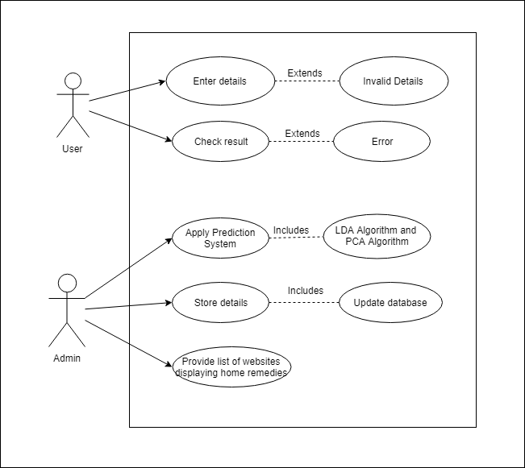

***3.4.2 Object model***

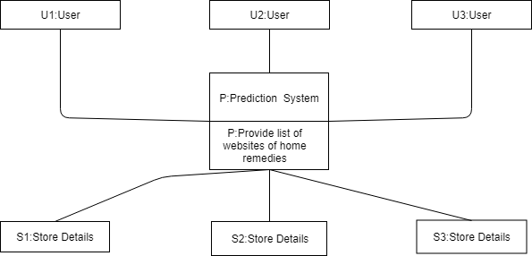

**3.4.3 User interface – navigational paths and screen mock-ups**

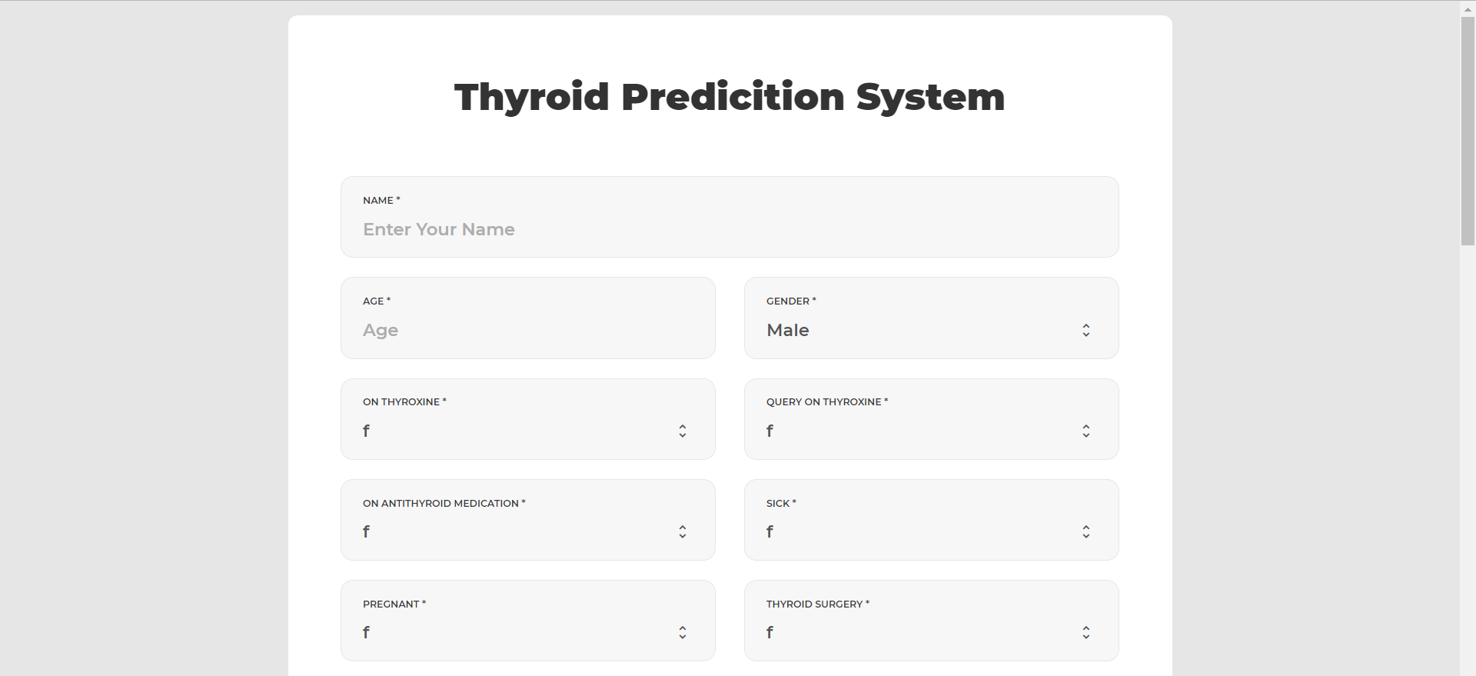

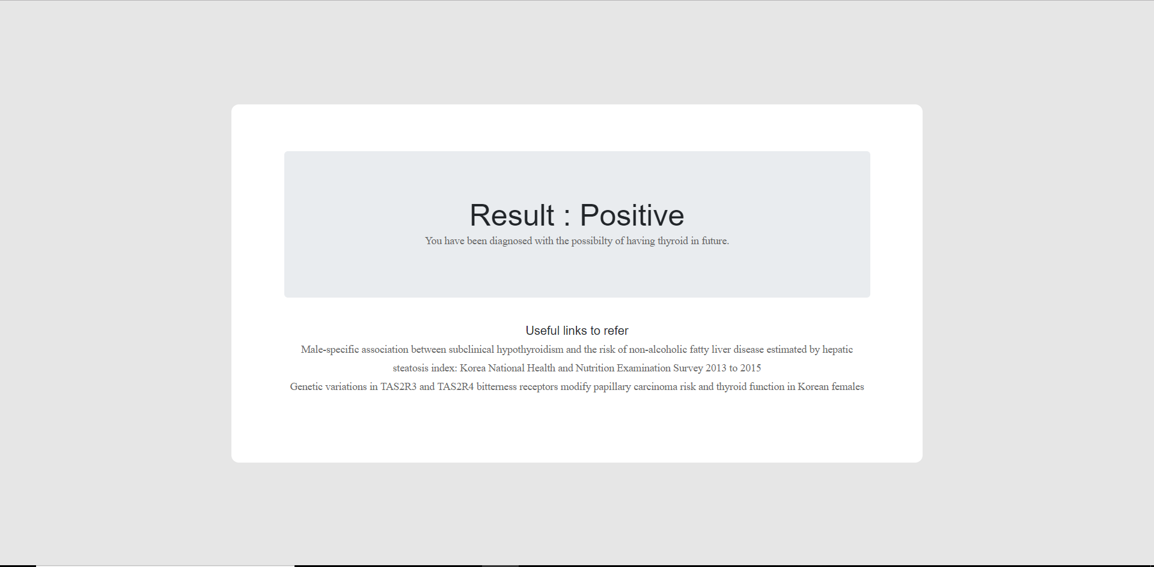

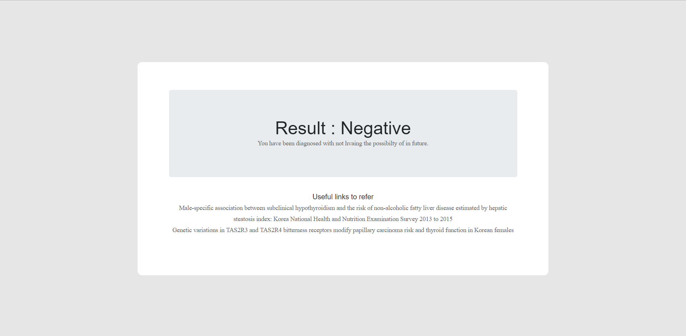

**3.2 Feasibility Study (FAD)**

**Introduction**

This section accounts for the feasibility study of the project from different perspectives, like it consists of the economic feasibility, technical feasibility, managerial feasibility and operational feasibility. It accounts for the obstacles that could be experienced and how to overcome them.

1. **Economic Feasibility:**

The EFS is composed of two required forms:

* **Business Case**

The Business Case provides an analysis of the business environment including-

Expected customers: People with similar symptoms as Thyroid

The nature of the business: Social

The Business Case also presents the benefits of the proposed project.

* **Cost Benefit Analysis**

The Cost Benefit Analysis summarizes the revenues and costs involved with the proposed project. As the proposed system will be used for the benefits of the people(users), no additional cost will be paid by them. No hardware system is included in our project, so the hardware cost gets minimized. Only minimal amount will be required by certain softwares. Hence, our system is Cost Efficient.

1. **Technical Feasibility:**

Technology used at front end: Python, HTML, CSS, Bootstrap

Technology used at Back end: Python

Resources Required: Manpower, Programmers, testers, debuggers

Software required: Testing Tools (to perform black box and white box testing), GitHub

Hardware required: PC for development, server for deployment

1. **Managerial Feasibility:**

Management support, user involvement, and commitment are key elements required to gauge managerial feasibility in the proposed project. The success and the profitability of the project partly depend on managerial competence of the major ingredients of the proposed project which are the users i.e. doctors and people with symptoms similar to Thyroid. The capability of the infrastructure of a process is to achieve and sustain the properties of isolation, atomicity, durability, consistency etc. in the matter of the data stored of the users and benefiters. Also, constant attention is required in the case of amount of log in files being created.

1. **Operational Feasibility:**

The proposed system is concerned with the people who are interested in prediction of disease by specifying the symptoms. The main task will be to provide disease diagnosis at early stages with higher accuracy. This system will be useful for disease diagnosis as it is indispensable for busy clinics. This system will be free for all the users. They can directly use the system. Providing prediction of thyroid disease is the main part of the system key which will be automated by using algorithms machine learning algorithms.

**3.3 Methodology**

Using PCA and LDA algorithms to classify data and predict the result based on the classification and machine learning.

**3.4 Technology**

We are going to use languages like HTML, CSS and Bootstrap studio for front end development and Python for back end development.

**3.5 Gantt Chart and Process Model**

1. **Gantt Chart**

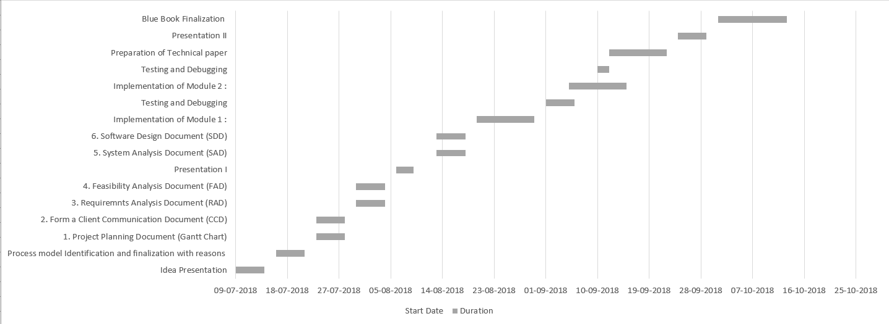

1. **PMI**

According to the analysis thyroid disease is growing day by day and nowadays it is most common in women. Disease diagnosis is very difficult task, it requires lot of experience and knowledge. It requires the physical presence of the person. It is a very difficult task to do without using a computer technology. Machine learning plays a major role in prediction. Hence by using prediction system the user does not have to be present physically and can predict the disease by providing the required inputs to the system. Also, the prediction of disease at an early stage will help the doctors to provide proper medication in time.

This proposed system is meant for prediction of Thyroid disease using machine learning techniques: PCA and LDA. Also, the system will provide a list of similar websites where they can check home remedies or blogs referring to similar problems based on the result.

Since we are familiar with the Agenda and Requirements, this system will be developed using waterfall software development model.

The development will be divided in five phases:

* Analysis
* Design
* Coding
* Testing
* Deployment

Waterfall model:

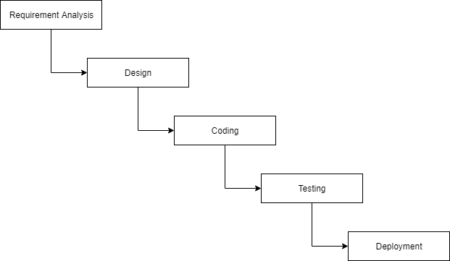

**3.6 System Analysis (functional model, structural model and behavioral model)**

**Functional Model: DFD**

**LEVEL 0:**

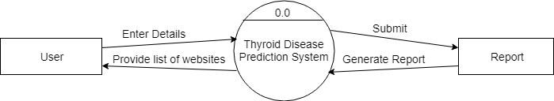

**LEVEL 1:**

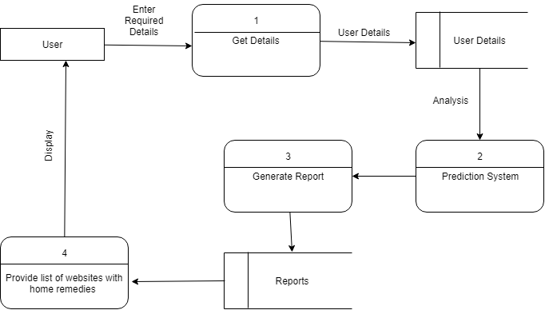

**Structural Model: Class Diagram and Deployment diagram**

**Class Diagram:**

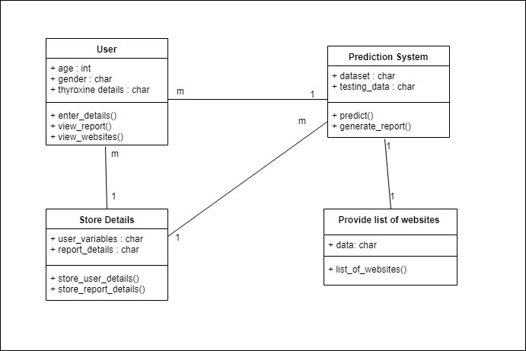

**Deployment Diagram:**

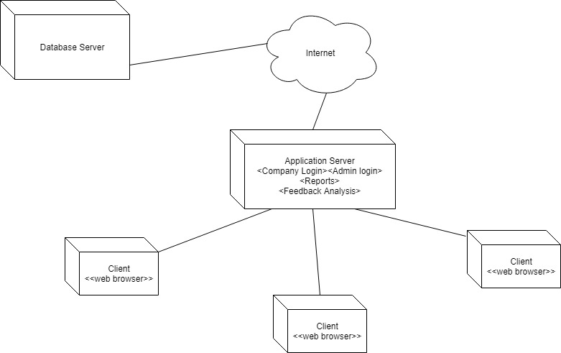

**Behavioral Model: Activity and Use case Diagram**

**Activity Diagram:**

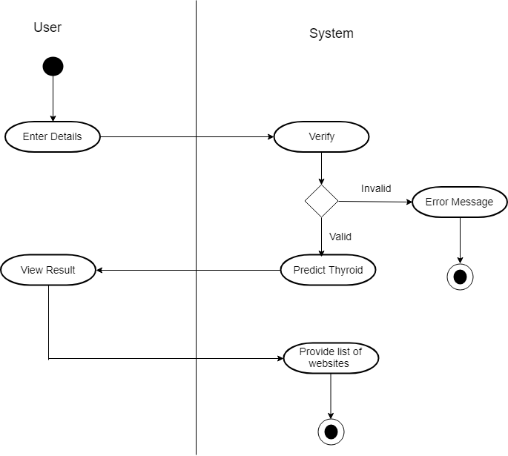

**Use Case Diagram:**



**Chapter 4**

**Design phase**

**4.1 Block Diagram**

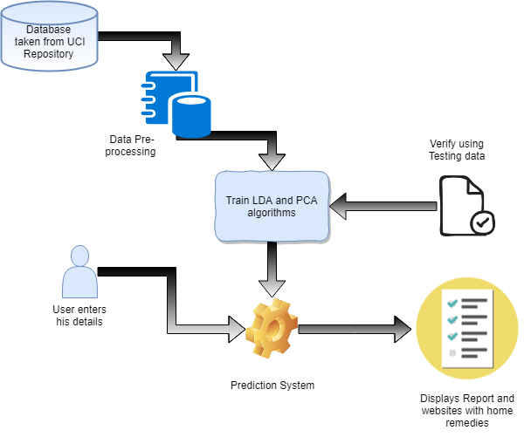

**4.2 Flowchart**

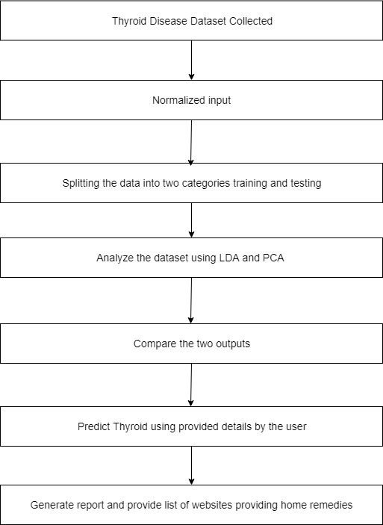

**4.3 User Interface Design (Snapshots)**



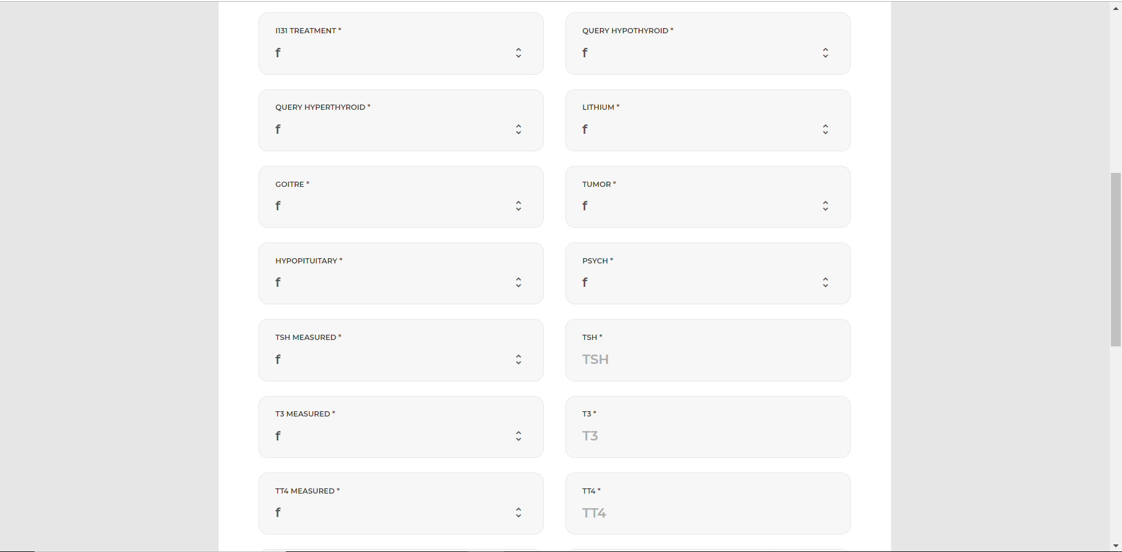

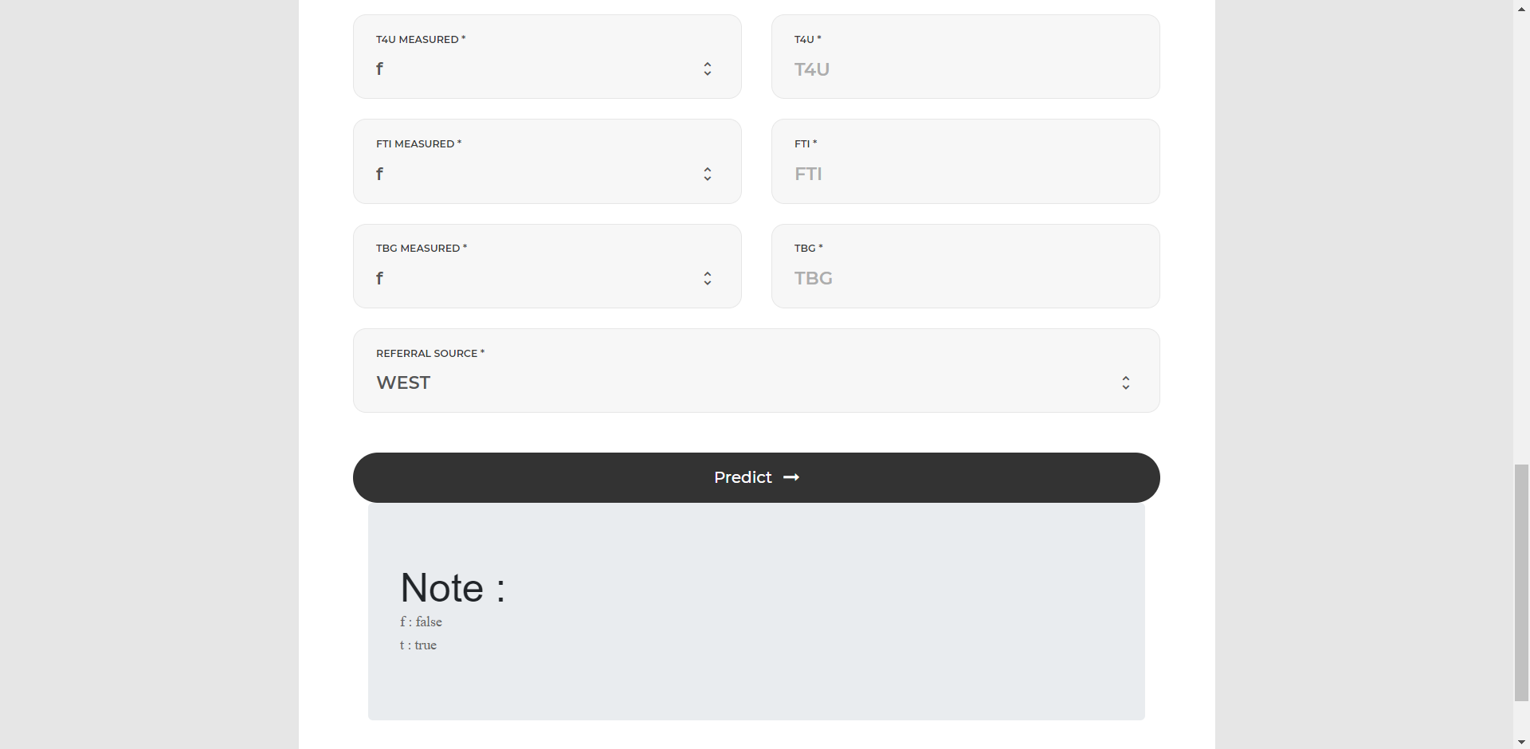





**Chapter 5**

**Conclusions**

In this project, we are building a Thyroid Disease Prediction system which uses machine learning techniques to predict Thyroid Disease. It consists of an information page which takes inputs from the user. It consists of information such as users name, age, gender, thyroxine details, antithyroid medication details, query hypo thyroid, query hyper thyroid, etc. After giving the input the user clicks on predict button. The system will predict whether the user will thyroid or not.

The system uses two machine learning algorithms: LDA and PCA. Using one of them which has greater accuracy it does prediction based on the user’s input. The system provides with the list of websites for further reference and also provides home remedies to cure thyroid.

Thyroid disease is one of the major diseases and prediction of it is very difficult task to complete without using a computer technology. Disease diagnosis plays a vital role and it is necessary for any busy clinician. Hence this system will be very useful for the users. Also, we can further advance this for predicting other diseases.

**References**

[1] Shaik Razia and M. R. Narasinga Rao, “Machine Learning Techniques for Thyroid Disease

Diagnosis - A Review”, *Indian Journal of Science and Technology, Vol 9(28), DOI: 10.17485/ijst/2016/v9i28/93705*, July 2016

[2] G. Rasitha Banu, “Predicting Thyroid Disease using Linear Discriminant Analysis (LDA) Data Mining Technique”, *Communications on Applied Electronics (CAE) (ISSN : 2394-4714), Volume 4– No.12*, January 2016

[3] Prerana, Parveen Sehgal, Khushboo Taneja, “Predictive Data Mining for Diagnosis of Thyroid Disease using Neural Network”, *International Journal of Research in Management, Science & Technology (E-ISSN: 2321-3264) Vol. 3, No. 2*, April 2015

[4] Dr. G. Rasitha Banu, M.Baviya, “PREDICTING THYROID DISEASE USING DATAMINING TECHNIQUE”, *International Journal of Modern Trends in Engineering and Research (IJMTER) Volume 02, Issue 03*, [March - 2015] e-ISSN: 2349-9745, p-ISSN: 2393-8161

[5] S. Umadevi, Dr.K.S. Jeen Marseline, “Applying Classification Algorithms to Predict Thyroid Disease”, *International Journal of Engineering Science and Computing, Volume 7 Issue No.10*, October 2017

[6] Anupama Shukla, Prabhdeep Kaur, “Diagnosis of thyroid disorders using artificial neural networks”, *2009 IEEE International Advance computing Conference (IACC 2009)* – Patiala, India, 2009, pp 1016-1020.

[7] Kousarrizi, Nazari MR, Seiti F, Teshnehlab M. “An experimental comparative study on thyroid disease diagnosis based on feature subset selection and classification.” *International Journal of Electrical & Computer Sciences.* 2012; 12(1):13–20.

[8] “UCI Machine Learning Repository of machine learning database”, *University of California, School of Information and Computer Science, Irvine, C.A.*

<http://www.ics.uci.edu/>.

[9] F. S. Gharehchopogh, M. Molany and F. D. Mokri,” USING ARTIFICIAL NEURAL NETWORK IN DIAGNOSIS OF THYROID DISEASE: A CASE STUDY”, *International Journal on Computational Sciences & Applications (IJCSA) Vol.3, No.4*, August 2013.

[10] <https://www.analyticsvidhya.com/glossary-of-common-statistics-and-machine-learning-terms/> (Visited on 12/10/2018 )

[11] <https://www.dezyre.com/data-science-in-python-tutorial/principal-component-analysis-tutorial> (Visited on 12/10/2018)

[12] <https://quizlet.com/94210487/endocrine-system-flash-cards/> (Visited on 13/10/2018)

[13] <https://www.medicinenet.com/hyperthyroidism/article.htm> (Visited on 13/10/2018)

[14] <https://ofm.wa.gov/sites/default/files/public/legacy/policy/40.40.htm> (Visited on 13/10/2018)

[15] <https://en.wikipedia.org/wiki/Principal_component_analysis> (Visited on 13/10/2018)

[16] <https://en.wikipedia.org/wiki/Linear_discriminant_analysis> (Visited on 13/10/2018)

[17] <https://en.wikipedia.org/wiki/Hypothyroidism> (Visited on 13/10/2018)

**Base Research Paper**

**Appendix A**

**Abbreviation and symbols**

1. LDA: Linear Discriminant Analysis
2. PCA: Principal Component Analysis
3. KNN: K-Nearest Neighbors
4. SVM: Support Vector Machine
5. UCI: University Of California Irvine
6. ANN: Artificial Neural Network
7. ML: Machine Learning
8. AI: Artificial Intelligence

**Appendix B**

**Definitions**

1. LDA: Linear discriminant analysis is a generalization of Fisher's linear discriminant, a method used in statistics, pattern recognition and machine learning to find a linear combination of features that characterizes or separates two or more classes of objects or events. The resulting combination may be used as a linear classifier, or, more commonly, for dimensionality reduction before later classification.
2. PCA: Principal component analysis (PCA) is a statistical procedure that uses an orthogonal transformation to convert a set of observations of possibly correlated variables into a set of values of linearly uncorrelated variables called principal components
3. Hypo-Thyroid: Hypothyroidism, also called underactive thyroid or low thyroid, is a disorder of the endocrine system in which the thyroid gland does not produce enough thyroid hormone. It can cause a number of symptoms, such as poor ability to tolerate cold, a feeling of tiredness, constipation, depression, and weight gain.
4. Hyperthyroid: Having an excessive amount of thyroid hormone resulting from an overactive thyroid gland or from taking too much thyroid hormone. Symptoms of hyperthyroidism can include increased heart rate, weight loss, depression, and cognitive slowing.